Java Package

1. [Java Package](https://www.javatpoint.com/package)
2. [Example of package](https://www.javatpoint.com/package#packageex)
3. [Accessing package](https://www.javatpoint.com/package#packageaccess)
   1. [By import packagename.*](https://www.javatpoint.com/package#packageaccess1)
   2. [By import packagename.classname](https://www.javatpoint.com/package#packageaccess2)
   3. [By fully qualified name](https://www.javatpoint.com/package#packageaccess3)
4. [Subpackage](https://www.javatpoint.com/package#packagesub)
5. [Sending class file to another directory](https://www.javatpoint.com/package#packageanotherdirectory)
6. [-classpath switch](https://www.javatpoint.com/package#packageclasspathswitch)
7. [4 ways to load the class file or jar file](https://www.javatpoint.com/package#packagewaystoload)
8. [How to put two public class in a package](https://www.javatpoint.com/package#packagetwopublic)
9. [Static Import](https://www.javatpoint.com/package#packagestaticimport)
10. [Package class](https://www.javatpoint.com/package-class)

A **java package** is a group of similar types of classes, interfaces and sub-packages.

Package in java can be categorized in two form, built-in package and user-defined package.

There are many built-in packages such as java, lang, awt, javax, swing, net, io, util, sql etc.

Here, we will have the detailed learning of creating and using user-defined packages.

Competitive questions on Structures in Hindi

Keep Watching

Advantage of Java Package

1) Java package is used to categorize the classes and interfaces so that they can be easily maintained.

2) Java package provides access protection.

3) Java package removes naming collision.

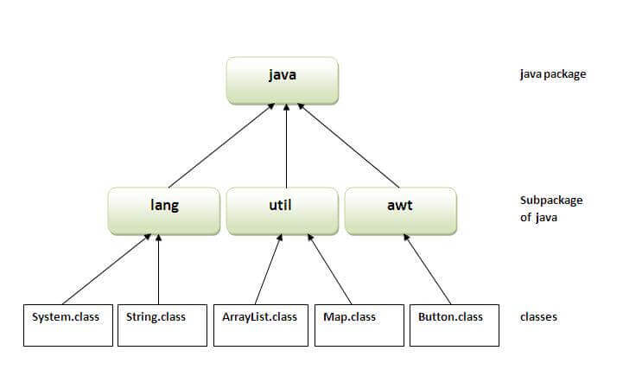

Simple example of java package

The **package keyword** is used to create a package in java.

1. //save as Simple.java
2. **package** mypack;
3. **public** **class** Simple{
4. **public** **static** **void** main(String args[]){
5. System.out.println("Welcome to package");
6. }
7. }

How to compile java package

If you are not using any IDE, you need to follow the **syntax** given below:

1. javac -d directory javafilename

For **example**

1. javac -d . Simple.java

The -d switch specifies the destination where to put the generated class file. You can use any directory name like /home (in case of Linux), d:/abc (in case of windows) etc. If you want to keep the package within the same directory, you can use . (dot).

How to run java package program

You need to use fully qualified name e.g. mypack.Simple etc to run the class.

|  |
| --- |
| **To Compile:** javac -d . Simple.java |
| **To Run:** java mypack.Simple |

Output:Welcome to package

|  |
| --- |
| The -d is a switch that tells the compiler where to put the class file i.e. it represents destination. The . represents the current folder. |

How to access package from another package?

There are three ways to access the package from outside the package.

1. import package.*;
2. import package.classname;
3. fully qualified name.

1) Using packagename.*

If you use package.* then all the classes and interfaces of this package will be accessible but not subpackages.

The import keyword is used to make the classes and interface of another package accessible to the current package.

Example of package that import the packagename.*

1. //save by A.java
2. **package** pack;
3. **public** **class** A{
4. **public** **void** msg(){System.out.println("Hello");}
5. }
6. //save by B.java
7. **package** mypack;
8. **import** pack.*;
10. **class** B{
11. **public** **static** **void** main(String args[]){
12. A obj = **new** A();
13. obj.msg();
14. }
15. }

Output:Hello

2) Using packagename.classname

If you import package.classname then only declared class of this package will be accessible.

Example of package by import package.classname

1. //save by A.java
3. **package** pack;
4. **public** **class** A{
5. **public** **void** msg(){System.out.println("Hello");}
6. }
7. //save by B.java
8. **package** mypack;
9. **import** pack.A;
11. **class** B{
12. **public** **static** **void** main(String args[]){
13. A obj = **new** A();
14. obj.msg();
15. }
16. }

Output:Hello

3) Using fully qualified name

If you use fully qualified name then only declared class of this package will be accessible. Now there is no need to import. But you need to use fully qualified name every time when you are accessing the class or interface.

It is generally used when two packages have same class name e.g. java.util and java.sql packages contain Date class.

Example of package by import fully qualified name

1. //save by A.java
2. **package** pack;
3. **public** **class** A{
4. **public** **void** msg(){System.out.println("Hello");}
5. }
6. //save by B.java
7. **package** mypack;
8. **class** B{
9. **public** **static** **void** main(String args[]){
10. pack.A obj = **new** pack.A();//using fully qualified name
11. obj.msg();
12. }
13. }

Output:Hello

Note: If you import a package, subpackages will not be imported.

If you import a package, all the classes and interface of that package will be imported excluding the classes and interfaces of the subpackages. Hence, you need to import the subpackage as well.

Note: Sequence of the program must be package then import then class.

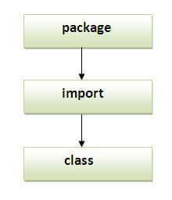

Subpackage in java

Package inside the package is called the **subpackage**. It should be created **to categorize the package further**.

Let's take an example, Sun Microsystem has definded a package named java that contains many classes like System, String, Reader, Writer, Socket etc. These classes represent a particular group e.g. Reader and Writer classes are for Input/Output operation, Socket and ServerSocket classes are for networking etc and so on. So, Sun has subcategorized the java package into subpackages such as lang, net, io etc. and put the Input/Output related classes in io package, Server and ServerSocket classes in net packages and so on.

The standard of defining package is domain.company.package e.g. com.JEEVA.bean or org.sssit.dao.

Example of Subpackage

1. **package** com.JEEVA.core;
2. **class** Simple{
3. **public** **static** **void** main(String args[]){
4. System.out.println("Hello subpackage");
5. }
6. }

|  |
| --- |
| **To Compile:** javac -d . Simple.java |
| **To Run:** java com.JEEVA.core.Simple |

Output:Hello subpackage

How to send the class file to another directory or drive?

There is a scenario, I want to put the class file of A.java source file in classes folder of c: drive. For example:

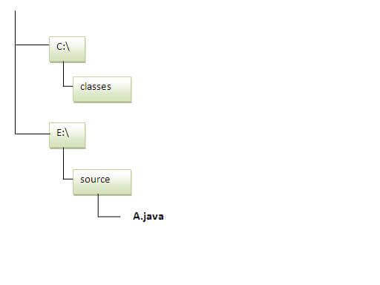

1. //save as Simple.java
2. **package** mypack;
3. **public** **class** Simple{
4. **public** **static** **void** main(String args[]){
5. System.out.println("Welcome to package");
6. }
7. }

To Compile:

**e:\sources> javac -d c:\classes Simple.java**

To Run:

|  |
| --- |
| To run this program from e:\source directory, you need to set classpath of the directory where the class file resides. |
| **e:\sources> set classpath=c:\classes;.;** |
| **e:\sources> java mypack.Simple** |

Another way to run this program by -classpath switch of java:

The -classpath switch can be used with javac and java tool.

To run this program from e:\source directory, you can use -classpath switch of java that tells where to look for class file. For example:

**e:\sources> java -classpath c:\classes mypack.Simple**

Output:Welcome to package

Ways to load the class files or jar files

|  |
| --- |
| There are two ways to load the class files temporary and permanent. |

* Temporary
  + By setting the classpath in the command prompt
  + By -classpath switch
* Permanent
  + By setting the classpath in the environment variables
  + By creating the jar file, that contains all the class files, and copying the jar file in the jre/lib/ext folder.

Rule: There can be only one public class in a java source file and it must be saved by the public class name.

1. //save as C.java otherwise Compilte Time Error
3. **class** A{}
4. **class** B{}
5. **public** **class** C{}

How to put two public classes in a package?

|  |
| --- |
| If you want to put two public classes in a package, have two java source files containing one public class, but keep the package name same. For example: |

1. //save as A.java
3. **package** JEEVA;
4. **public** **class** A{}
5. //save as B.java
7. **package** JEEVA;
8. **public** **class** B{}